AUDIO VIDEO HUB

# .Bhushan Chaudhari

*Dept. of Information Technology SVKM’s IOT Dhule*

Dhule, India

[bhushan.chaudhari@svkm.ac.in](mailto:bhushan.chaudhari@svkm.ac.in)

# Lokesh Dipak Patil

*Student,IT SVKM’s IOT Dhule*

Dhule, India [Lok](mailto:Lokesh.patil63@svkmmumbai.onmicrosoft.com)[esh.patil63@svkmmumbai.onmicrosoft.com](mailto:esh.patil63@svkmmumbai.onmicrosoft.com)

# Harshit Arun Gujarathi

*Student ,IT*

*SVKM’s IOT Dhule*

Dhule, India

[Harshit.gujrathi67@svkmmumbai.onmicrosoft.com](mailto:Harshit.gujrathi67@svkmmumbai.onmicrosoft.com)

# Dhiraj Mahendra Patil

*Student, IT SVKM’s IOT Dhule*

Dhule, India

[Dhiraj.patil62@svkmmumbai.onmicrosoft.com](mailto:Dhiraj.patil62@svkmmumbai.onmicrosoft.com)

# Chetan Vilas Khairnar

*Student,IT SVKM’s IOT Dhule*

Dhule,India [chetan.khairn](mailto:CHETAN.KHAIRNAR68@svkmmumbai.onmicrosoft.com)[ar68@svkmmumbai.onmicrosoft.com](mailto:AR68@svkmmumbai.onmicrosoft.com)

***Abstract* —**

Content creators manage and edit video in specific formats where the creator faces the quality issue, more time consumption in searching for similar content on multiple websites A GUI system that allows content creators to browse a wide range of video templates, organized by categories. They can download them along with their audio tracks if desired. It would have a simple and intuitive interface that enables users to search for video templates by category or keyword. The available categories could include a range of themes, such as educational, promotional, or entertainment, among others. Once users have found a template they like, they can preview it and customize it according to their specific needs. Customization options include editing text, adding images or videos, and changing music or audio track. After the template has been customized, users can download the final video file, along with its audio track, if they choose to. They would have the option to download the video and audio together, or just the video or audio alone. Overall, this GUI system would provide a user-friendly and efficient way for content creators to browse, customize, and download video templates that match their specific needs, while also allowing them to access the audio tracks separately if needed.

1. INTRODUCTION

A graphical user interface (GUI) that assists content creators in creating and editing their content by optimizing video quality and providing multiple download versions. The GUI typically includes a variety of tools and features which allow creators to craft their content in a more efficient and effective way[10]. The GUI may also include features for organizing and managing content, such as a content calendar or workflow management tool[5]. Content creators can use the GUI to collaborate with others on their content, such as team members or clients. They can also share drafts and revisions in real time. A well-designed content creator GUI should be intuitive and user-friendly, allowing creators to focus on their creative process rather than struggling with technical challenges[8]. The GUI should be able to provide access to resources and support, such as tutorials, FAQs, and customer support. This will help creators get the most out of the tool. Additionally, users can upload content templates based on other users' interactions, and they get bonus points as fame as well.

## A. Problem Statement

Content creators often need to create visually appealing video content quickly and efficiently. However, finding and downloading suitable video templates can be time-consuming and challenging, especially if they have to browse multiple websites or platforms to find their content

1. LITERTAURE SURVEY

Throughout the course of this project, we have gone through various literature surveys/reviews. We have come across many different concepts related to this project as follows:

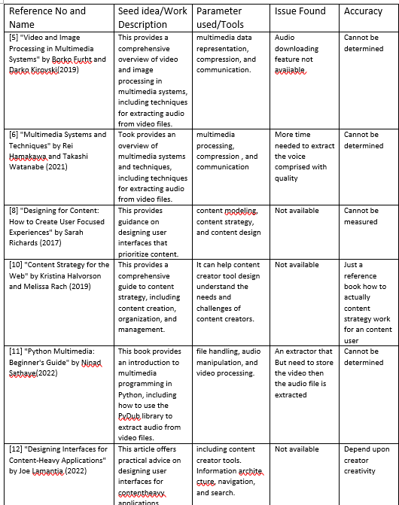

1. *CONTENT CREATOR :* This help the both the actors (content user and admin)
2. *Content user:* – For viewing the profile of the creator and can request the admin for new content video on demand
3. *Admin:* – To solve the query by performing the task at limited time and admin will verified the content
4. *ADMIN:* where the major task is to solve the Content user query at limited time and assign the task to content creator and rewarding them with some points

IV. APPLICATION

***A. Applications***

***1) Social media platforms****: Users can quickly create and share material via content creator interfaces on social media platforms like Instagram, YouTube, and TikTok.*

***2)*** *Online businesses can employ content creator interfaces that make it simple for suppliers to upload pictures of goods and descriptions.*

***3) Blogging platforms:*** *Websites like WordPress and Blogger provide content creator interfaces that let bloggers publish blog entries without needing any previous knowledge of coding.*

V. CONCLUSION

***A. Conclusion***

It provides a user-friendly interface that allows content creators to easily create and publish content without the need for advanced technical skills. Additionally, Streamline the content creation process by providing a centralized platform for collaboration, editing, and sharing. By focusing on quality and choosing the right platform, you can ensure that your content creator videos reach the right audience and get the most out of them. This can save time and effort while ensuring that the content is professional-looking and consistent. Great way to improve the efficiency and effectiveness of content creation

***B. Limitation of Project***

Below are listed some limitation of an our system that every users need to follow

1) *The copyright issue* : The copyright issue may be occur depending on which platform the user going to upload

*2) The Trending issue:* The trending depending on the content creator while the video is supported screen recording or not

*3) The Quality issue:* The quality depending on the quality we founds

1. METHODOLOGY

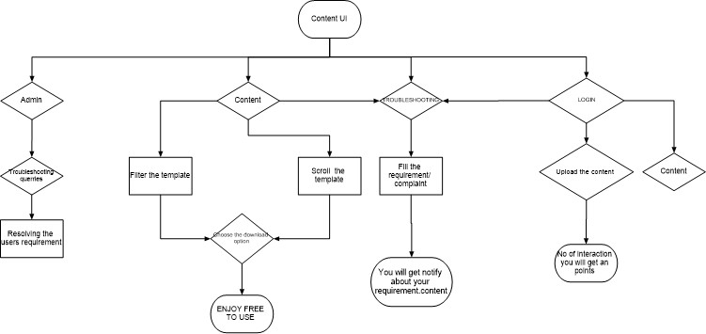

1. ***Admin****:* Need to login first updating the video

filter approve the content creator task accomplished request

and providing the topic quality contentThe Content user can

scroll and alsofilter the search template and

choosing thedownload option as audio or

only video

1. ***Content creator****:* Content creator can also act as content

user can scroll and download the content but as the named suggested

content creator need to login first to upload content filling the

necessary details and the creator need to wait for admin response

request Creator can also create his/her profile for viewing the

points

1. ***Content user****:* Content user can scroll and filter the meme template easily select the download option and used this in your content

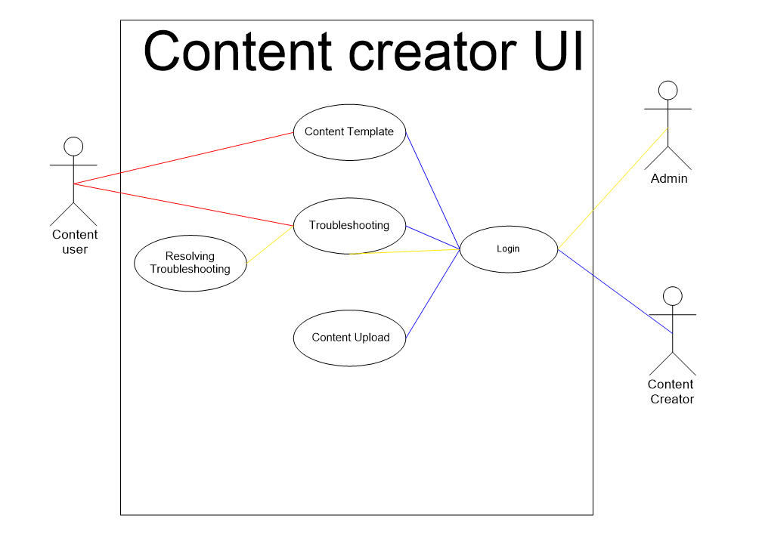

1. *Social media platforms::* Social media platforms like Instagram, YouTube, and TikTok can use content creator interfaces to allow users to create and upload content easily.
2. *E-commerce websites::* Online stores can use content creator interfaces to allow vendors to upload product images and descriptions easily.
3. ***Blogging platforms:****:* Blogging platforms like Word- Press and Blogger can use content creator interfaces to allow bloggers to create and publish blog posts without any coding knowledge.
4. CONCLUSION

## Conclusion

It provides a user-friendly interface that allows content creators to easily create and publish content without the need for advanced technical skills. Additionally, Streamline the content creation process by providing a centralized platform for collaboration, editing, and sharing. By focusing on quality and choosing the right platform, you can ensure that your content creator videos reach the right audience and get the most out of them. This can save time and effort while ensuring that the content is professional-looking and consistent. Great way to improve the efficiency and effectiveness of content creation

1. REFERENCES
2. .Yansong Cui and Lianpin Jiang, ”Design of batch audio/video conver- sion platform based on JavaEE”,IOP – Institute of Physics ,(2018).
3. Jenifer Tidwell ,”Designing Interfaces: Patterns for Effective Interaction Design”,O’Reilly Media; 2 edition, (2011)
4. Yao Wang, Joˆrn Ostermann, and Ya-Qin Zhang, ”Video Processing and Communications” , (2019 ).
5. Jesse James Garrett ,” The Elements of User Experience”, New Riders Publishing,(2019).
6. Borko Furht and Darko Kirovski , ”Video and Image Processing in Multimedia Systems”, Springer-Verlag New York Inc,(2019).
7. Rei Hamakawa and Takashi Watanabe”Multimedia Systems and Tech- niques” , (2021).
8. Kim Goodwin , ”Designing for the Digital Age: How to Create Human- Centered Products and Services”, Wiley Publishing, Inc. ,(2020)
9. Sarah Richards, ”Designing for Content: How to Create User- Fo- cused Experiences”, Content Design London, (2017).
10. Borko Furht, ”Multimedia Processing: Algorithms and Systems”,(2021).
11. Kristina Halvorson and Melissa Rach, ”Content Strategy for the Web”, New Riders Publishing, (2021).
12. ] Ninad Sathaye, ”Python Multimedia: Beginner’s Guide”, Packt Pub- lishing Limited, (2022).